Justin Murphy

Octave Graphing

I changed to a simpler function that I could graph easier to show more data. The equation is now able to be seen on the graph instead of immediately jumping off the screen as fast as possible. Then, we start the entire equation by generating and inputting the graph we want to generate. Then we start a random generator that chooses from Zero to Fifty and inputs it into the Salter. Then, we change all the inputs and display values of the figure itself and build the first Figure. We label the Graph, turn on the Grid to make it look better, and it outputs the graph.

To get the output of the graph, and if you want the data to output into a CSV file for later, you should make the data into columns, for easier readability for Excel and Google Sheets specifically. Then, you name the file that gets outputted with the csvwrite command and you output the data using Retval, which was used in the beginning and needs to be used in order to get any kind of output from Octave itself.

Zoomed Out Graph:

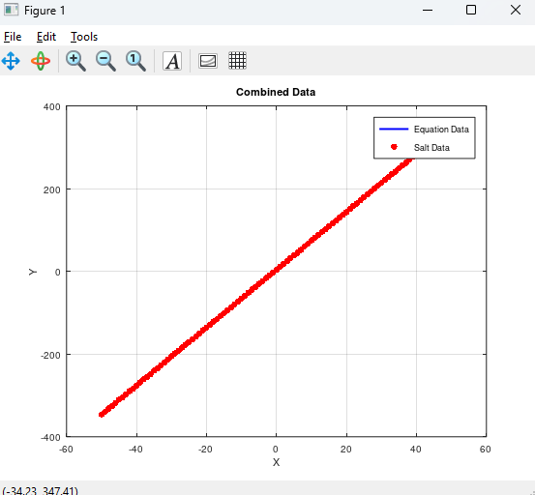

Zoomed In Graph:

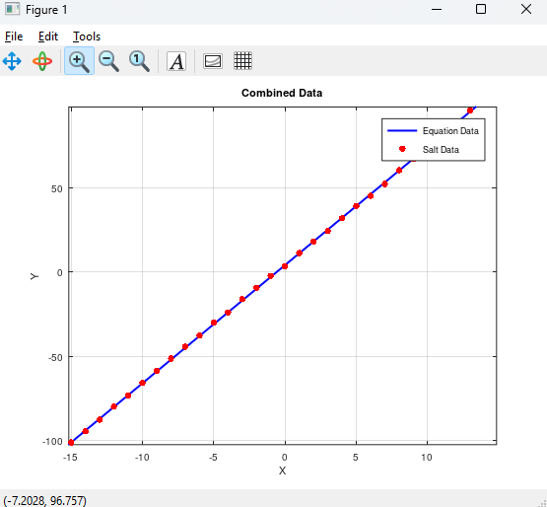

As you can tell, it added salt data to the ends of the line, and it isn’t perfect but they are close since I only made them be able to generate from -1 to 1 from the point. Trying to learn from the previous part, I made them a lot closer together, but still separate. After, we make another figure for the Smoothed data, which we use the Window Size and the Salted values to fix, and use the output values and graph.

Zoomed Out Graph:

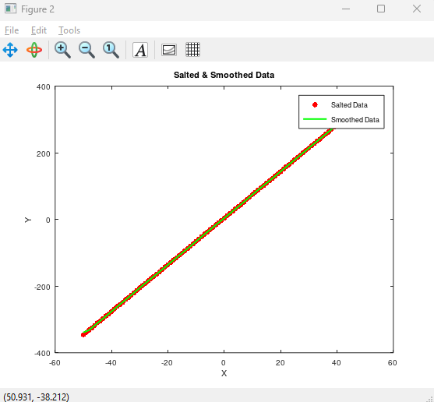

Zoomed In Graph:

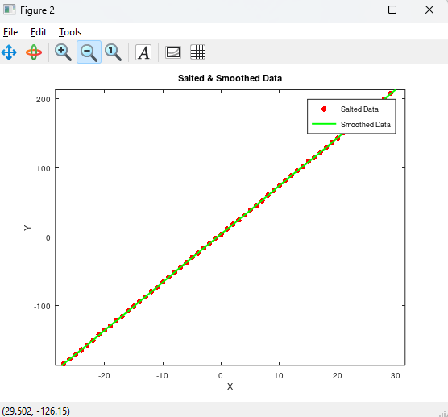

It changed the Data to be Green, to show the difference between the two figures, but it shows a bit more in depth that it changed the line slightly to match the Salted data values. Seeing the difference between the two, it isn’t that great of a change visually, but it does change slightly throughout the graph entirely.